Student Name: __________________
Class and Section __________________
Total Points (25 pts) __________________
Due: Final Project April 27, 2011 before the class

Final Project: Weighted Graph Visualization Learning Tool

CSCI 2410 Data Structures and Algorithms
Armstrong Atlantic State University

Problem Description:

Develop an applet as shown in the following figure.
http://www.cs.armstrong.edu/liang/animation/WeightedGraphLearningTool.html

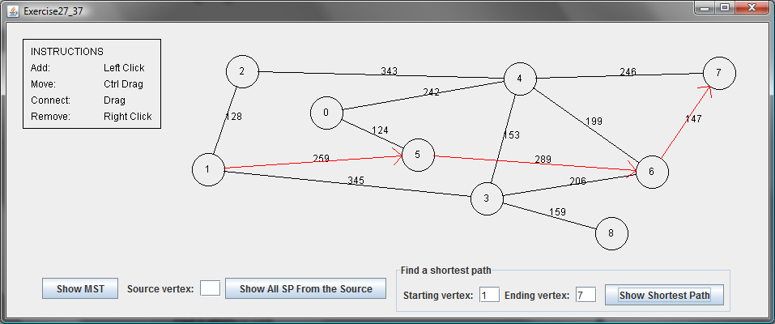

Requirements:
(1) The radius of each vertex is 20 pixels.
(2) The user clicks the left-mouse button to place a vertex centered at the mouse point provided that the mouse point is not inside or too close to an existing vertex.
(3) The user clicks the right-mouse button inside an existing vertex to remove the vertex.
(4) The user presses a mouse button inside a vertex and drags to another vertex and then releases the button to create an edge and distance between the two vertices is also displayed.
(5) The user drags a vertex while pressing the CTRL key to move a vertex.
(6) The vertices are numbers starting from 0. When a vertex is removed, the vertices are renumbered.
(7) You can click the Show MST or Show All SP From the Source button to display a MST or SP tree from a starting vertex.
(8) You can click the Show Shortest Path button to display the shortest path between the two specified vertices.

Paste your source code here:

Screen shots (Give some screen shots to show how the program work)

What to submit?

1. Compile and Submit to LiveLab (you must submit the program regardless whether it complete or incomplete, correct or incorrect)

Name your applet Exercise29_17

2. Fill in self-evaluation:

- Can your program display the GUI? _______________
- Can your program create vertices? _______________
- Can your program connect vertices? _______________
- Can your program remove vertices? _______________
- Can your program move vertices? _______________
- Can your program display MST? _______________
- Can your program display single-source all SPs? _______________
- Can your program display a shortest path? _______________
- Can your program display arrowed lines correctly? _______________

